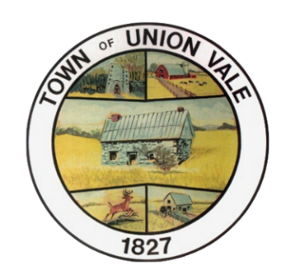

Union Vale Town Board
Meeting Agenda
September 16, 2026 7:30pm

- Call to order/Salute flag
- Approve minutes 8/19/2026
- Supervisor report
- Board member reports
- Town Clerk report
- Highway Superintendent report
- Animal Control report
- County Legislator report
- Public comment on agenda items
- New Business
- Consider JB’s II liquor license application
- Discuss Planner proposal for Master Plan/Code updates
- Old Business
- Resolution to purchase replacement Parks Dept mower
- Public comment on Town issues
- Motion to pay bills
- Executive session (pending)
- Next meeting October 7 at 7:30pm
- Adjourn

